**The TALEND workspace is the GIT repository itself**

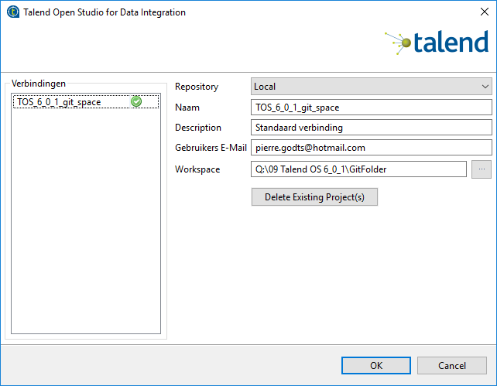

In that workspace all TALEND projects are created.

So all those TALEND projects are automatically in the GIT repo.